DUNS TEW PARISH COUNCIL

Minutes of the Parish Council meeting held

on Monday 4 November 2024 at 7:30 pm in the Village Hall

for the transaction of the following business:

Present: - Cllr. Stapleton (Chair), Cllr Jackson, Cllr Landless, Cllr Semple Cllr. Howard, Cllr Hall
In attendance: Mrs. Friend (Clerk).

Minute Number | Agenda Number | Minute
24.113 | 1 | Apologies for absence:  It was RESOLVED that there was an apology from Cllr Tickle (Vice Chair),
24.114 | 2 | Declarations of Pecuniary Interest and Requests for Dispensation  It was RESOLVED that there were no declarations of pecuniary interest.
24.115 | 3 | Minutes of the Last Meeting:  It was RESOLVED to sign the minutes at the next meeting to give council time to read through. Minutes dated 2nd September 2024.
24.116 | 4 | Public Participation:  There were 4 members of the public present.  - Raised an issue on the Website and changing details for the Newsletter editor.  - Is there any update on the manor application which there has been no update on.  - Blooms and tunes festival is a very family friendly, community orientated event that is becoming a lovely event for the 2nd annual.
24.117 | 5 | County and District Councillors Reports:  District Councillor David Rogers attended the meeting:  The next parish liaison meeting is now online and not in person. Duns tew isn’t a direct target for housing.  There are large sums of money that Oxfordshire County Council are holding onto which Cherwell are yet to respond to.
24.118 | 6.a | Finance: Payments due for the period September/October 2024:  It was RESOLVED that the payments for the period September/October 2024, as listed below, were correct and approved for payment. It was RESOLVED that all invoices/relevant papers were signed and then approved on-line by Cllrs Simple and Jackson  Bank reconciliation for September/October was signed by Cllr Stapleton

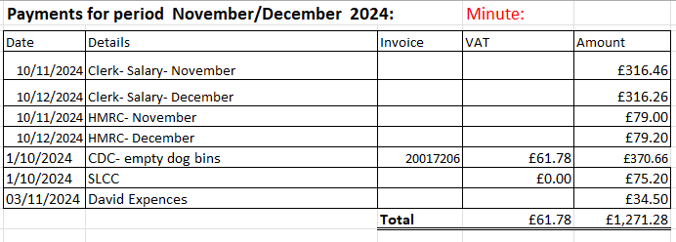

Payments (Direct Debits) for the period September/October 2024:

Date | Details | Reference | Amount
14/10/2024 | Scribe | Direct Debit | £14.40
14/10/2024 | Lloyds Card | Direct Debit | £3
14/10/2024 | Scribe | Direct Debit | £14.40
 |  | Total | £31.80

24.119 | 6.b | Finance: Income Received in the period September/October 2024:  It was RESOLVED that the income for the period September/October 2024, as listed below, was correct.

Date | Details | Reference | Amount
15/10/2024 | Cherwell Lottery |  | £5.00
 |  | Total | £5

24.120 | 6.c | Financial Review: 2024/2025.  Current Bank Balance = £35,522.95  The Financial Review and bank balance were NOTED.

24.121 | 6.d | Review of Reserves: 2024/2025.  It was RESOLVED to NOTE the updated reserves.

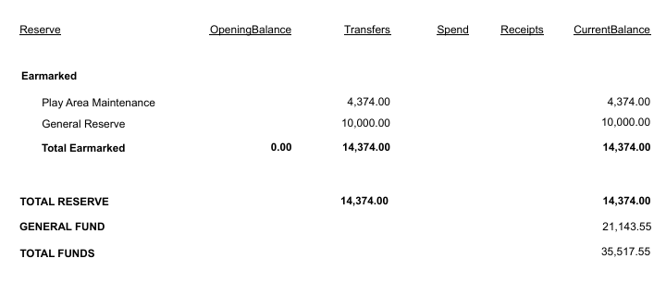

24.122 | 6.e. | To consider approval of new Financial Regulations  It was RESOLVED to approve and adopt the new regulations

24.123 | 6.f. | To set budget and precept for 2025-2026 financial year  It was RESOLVED to keep the precept the same £22,000 budget numbers were finalised.

24.124 | 6.g. | To consider approval for VAS signs  It was RESOLVED to approve purchase the signs and invoice throughout the month

24.125 | 6.h. | To consider NALC 24-25 pay rise:  It was RESOLVED to approve up national uplift and backdate pay

24.126 | 6.i | To consider grant application for Blooms and Tunes Festival  It was RESOLVED to approve

24.127 | 6.J | To consider adoption of biodiversity policy  It was RESOLVED to defer to next meeting

24.128 | 7 | Clerks Report

Item: | Action Required: | Result:

Jubilee Bench | Jubilee Committee trees (as part of the Queen’s Canopy) and plaque in Village Hall funded by £1460.03 remaining from the Jubilee celebration event. | ACTIONED.  Cyan bench chosen. Cllr. Landless bench has been delivered and awaiting build
Drains/Flooding at Longfield/Main Road. | RESOLVED to place under observation.  Floods over Christmas. To determine further action if required. | On going – see above Cllr Rogers update.
Councillors Priority Fund | VAS (Solar powered). | Awaiting reply from OCC
Website | Updating of the website | Action: clerk to speak with Cllr Hall and get it updated
Bus parking | To discuss the issues with school bus parking around the village | Clerk action: To respond to the resident

 | 8 | Parish Matters:
24.129 | 8.a. | Amenities: - update Cllr. Hall.  Nothing to report
24.130 | 8.b | Community: update Cllr. Semple.  Nothing to update.  Jubilee left over money with the idea to spend it on a table tennis table to be used in the village hall. It was RESOLVED to support.
24.131 | 8.c | Planning: Cllr.  Nothing new to update  Marquee is still erected Action: clerk to speak to the planning department.

Reference No. | Location | Proposal/ Description | Validated | Status
24/01485/F | Barn End 5 Field Court Duns Tew OX25 6LD | Installation of a free standing heat pump (11kw single unit) to the front of the property, 2m from the boundary - positioned in front of the old boiler flue | 25/10/2024 | Under Consultation
24/02845/F | Needle Cottage 25 Main Street Duns Tew Oxfordshire OX25 6JR | Single storey rear extension + replacement workshop & potting shed | 25/10/2024 | Under Consultation
24/01313/LB | Halcyon Mews Main Street Duns Tew OX25 6JL | RETROSPECTIVE - Change of colour for windows and doors to, 'Farrow & Ball' 'Light Grey' and change of pvc door to a more traditional wooden stable door | 15/10/2024 | Under Consultation
24/02407/ADV | White Horse Inn Main Street Duns Tew Bicester OX25 6JS | Installation of replacement signs to include 1x pictorial projecting sign and 2x car park directional signs | 06/09/2024 | Under Consultation
24/02408/LB | White Horse Inn Main Street Duns Tew Bicester OX25 6JS | Installation of replacement signs to include 1x pictorial projecting sign and 2x car park directional signs | 06/09/2024 | Under Consultation

24.132 | 8.c | Planning/MCNP: update Cllr. Tickle.  Update has been emailed around the councillors for the MCNP
24.133 | 8.d | Services: Cllr Jackson.  Gave an update on the North Aston Junction and that we now have some money in the 25/26 financial year to support some safety changes.
24.134 | 8.e | Environment: Cllr Howard.  - Sustainable Duns Tew have applied for a grant from CDC and are awaiting update.  - The footpath has been sorted.

Agenda Item | 10. | Correspondence

Nothing new to add

Other Correspondence : | Sent to:
Rural Funding Digests - regular email updates forwarded as received. | Full Council
The Rural Bulletins/Rural Services Network - regular email updates forwarded as received. | Full Council
SLCC News Bulletins - regular email updates forwarded as received. | Full Council
OALC updates and news - regular email updates forwarded as received. | Full Council
Public Sector News and Analysis emails. Regular email updates forwarded as received. | Full Council
Police and Crime Bulletins - regular email updates forwarded as received. | Full Council
Parish related information from Cherwell District Council or Oxford County Council. Forwarded as received. | Full Council
Planning Applications and Decisions from Cherwell District Council. Forwarded as received. | Full Council
Planning Applications and Local Plan information. MCNF. Forwarded as received. | Full Council

Next Meeting: 6 January 2025.

The Meeting finished at 20:44.

Signed by Chairman……………..

